Company Name:

Account Number:

Address:

Staff contact name(s):

Emergency Contact Name:

24-hour Emergency Phone Number:

_________________________________________________________________________________

In consideration of DHL Express, its affiliates, associates,
subsidiaries, authorized agents and sub-contractors (hereinafter collectively referred
to as “DHL”) agreeing, at our request, to accept this “Exempt (Human/Animal) Patient
Specimens” shipment of Hawb ______________________________ as undertaken by our
company, we, the undersigned, hereby confirm that:

1. We accept that the DHL Standard Terms and Conditions of Carriage will apply as
between us and DHL in respect of all carriages of Exempt Human/Animal Specimens
which we may request DHL to carry on our behalf. Any person who has knowledge of
and makes use of the Account shall be deemed to have entered into a contract with
DHL on our behalf and as our agent. We agree that we will be deemed as the
Shipper as referred to or defined in the DHL Standard Terms and Conditions of
Carriage. In the event of any conflict between the DHL Standard Terms and
Conditions of Carriage and the terms and conditions of this Authority Request Form,
the terms and conditions of this Authority Request Form shall prevail to the extent of
such conflict.

2. We will comply with any applicable laws and regulations set forth by the
Country/States of origin, transit and destination. We accept and understand that
offering articles or substances in violation of these laws and regulations may lead to
the imposition of penalties and the incurrence of fines and we accept full responsibility
for such violation.

3. We understand that DHL may arrange for additional insurance for a shipment upon
our written request and at our expense.

4. We confirm truthfully and correctly, our specimens do not contain infectious
substances and are unlikely to cause diseases in humans or animals and are not
subject to the IATA Dangerous Goods Regulations and it meets the exemption clause
3.6.2.2.3.1.

5. We confirm truthfully and correctly, our specimens meet at least one of the
appropriate exemption clauses as indicated in the below table IATA Dangerous
Goods Exemption Clauses listed under section 3.6.2.2.3 :

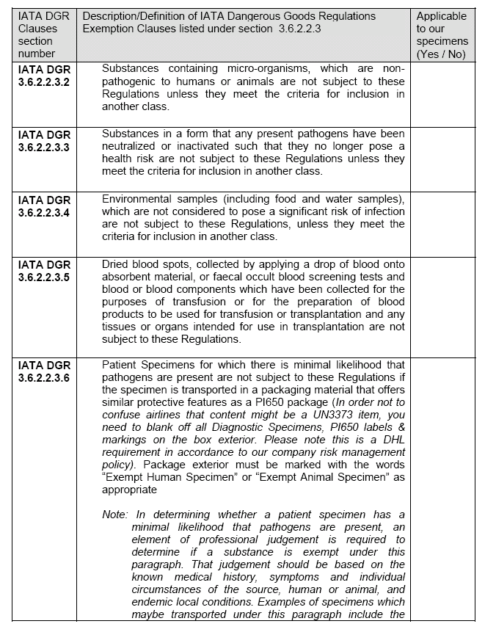

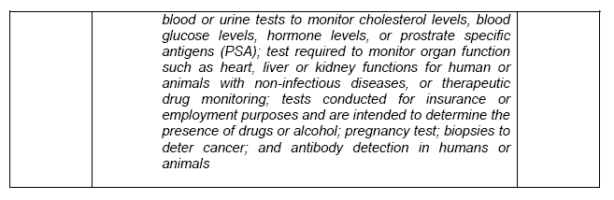

We shall ensure that:
1. DHL will not be requested to carry dangerous goods commodities forbidden for
transport as detailed in the IATA Dangerous Goods Regulations.
2. DHL will not be requested to carry Infectious Diagnostic Specimens
(UN2814/UN2900/UN3373) under this Authority Letter for Exempt (Human/Animal)
Patient Specimen.
3. We will identify, correctly and fully, any dangerous articles and dangerous substances
within the consignment if there are any.
4. We will classify any dangerous goods by determining under which of the nine UN
Hazard classes they fall under and, where relevant, determine if any subsidiary
hazards exist.
5. Where relevant, we will assign each item of dangerous goods to one of the three
packing groups and the correct packing instructions within the assigned class or
division
6. The package containing Exempted (Human/Animal) Patient Specimens possess the
same protective packaging features as offered by a package that meets IATA
Dangerous Goods Regulations Packing Instruction 650.
7. The statement on the packaging exterior clearly states that the contents are “Exempt
Human Specimens” or “Exempt Animal Specimens” as appropriate.
8. The DHL House Airway bill states the wording “Exempt Human (or “Animal” as
appropriate) specimen. Not Restricted as per IATA DGR section 3.6.2.2.3.6”
9. The Shipper understands the definition of IATA DGR Exemption clauses state in
section 3.6.2.2.3.
10. DHL will not be given any dangerous goods other than Exempt (Human/Animal)
Specimens, unless authorized by a separate DHL approval.

We shall indemnify and hold DHL harmless in respect of all losses, damages, costs,
expenses, fines and penalties arising out of and/or in connection with and/or resulting from:

(i) the breach of any of the above terms and warranties;

(ii) dangerous goods which are:

a. not declared as such,
b. improperly packaged,
c. not accompanied by appropriate documentation,
d. mislabeled or
e. transported without the prior written approval of DHL; and

(iii) the carriage of any shipment upon our request.

We understand and agree that the shipment shall only be deemed to be approved for carriage
by DHL once the relevant airline company has accepted the shipment for carriage. Any time
prior to the acceptance for carriage by the airline company, DHL shall have the right to reject
the shipment for carriage without DHL being liable to us or any other party for any damages
for such rejection, and we hereby agree to indemnify DHL in respect of all losses, damages,
costs and expenses arising out of or relating to any claims by any party in respect of such
rejection.

DHL shall have the right at any time and in its absolute discretion to withdraw the Service and
terminate the Account immediately without any notice.

Declared on behalf of Shipper: Declared by qualified medical
practitioner:

Signed: Signed:

Printed Name: Printed Name:

Title / Designation: Title / Designation:

Place: Place:

Date: Date:

